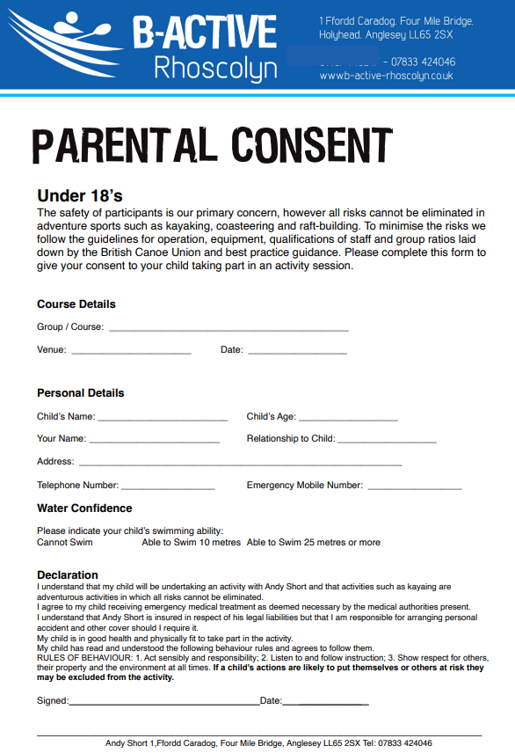
Please return these forms to your form tutor by 23rd March 2026
Please be honest about this question – it really matters. If your child cannot swim, they will still get to participate.
(please circle correct date for your child’s Tynny trip)
Anglesey 23 June, 25 June, 30 June, 2 July, 9 July 2026
Lymm High School Ty’n-y-Felin coasteering/kayaking

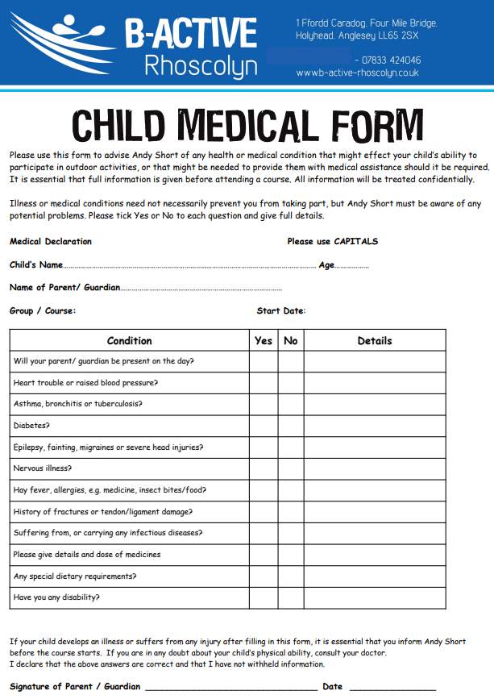
Please also inform Miss T Taylor at school of any new illnesses or injuries after filling out this form.)
(This should be their age on the date below)
(please circle)
23 June, 25 June, 30 June, 2 July, 9 July 2026
Lymm High School coasteering/kayaking

